**Random order controller:**

First we need to record the test we are done using Blaze meter or by setting proxy we can done.

After recording the tests we can download those recordings with extensions as .jmx,iand the recording will download and show in downloadings.

Now open jmeter and browse the location and open the recording in JMeter,Now right click on thread and create –add-logic controller-Random order controller.

We can copy paste the tests as we needed.

And the tests added in the random controller will execute random ly but executes all tests.

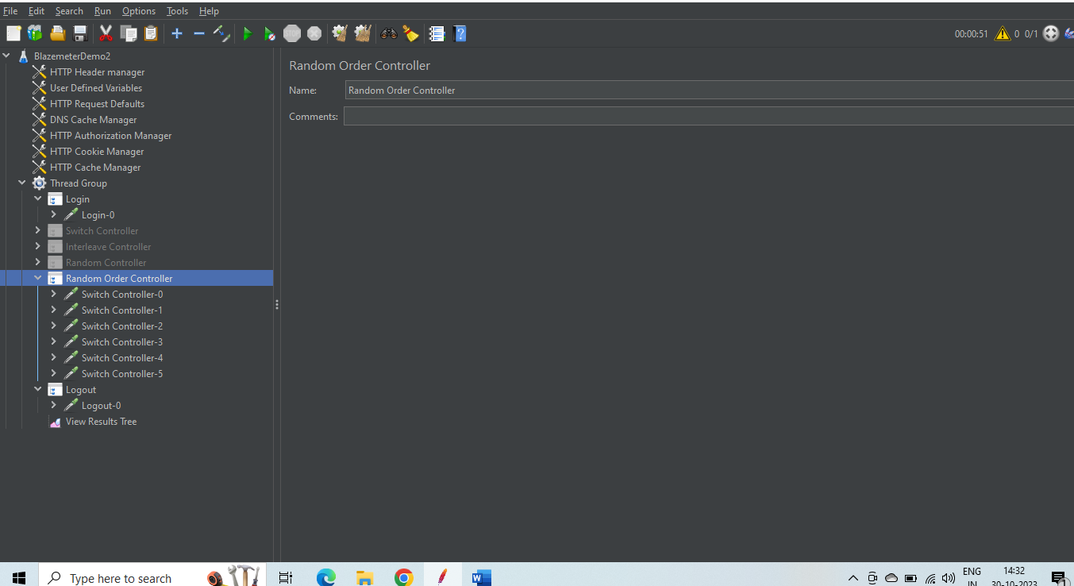

As we can see below that all the test present in the random order controller executed but not in the order its executed randomly but all executed.

